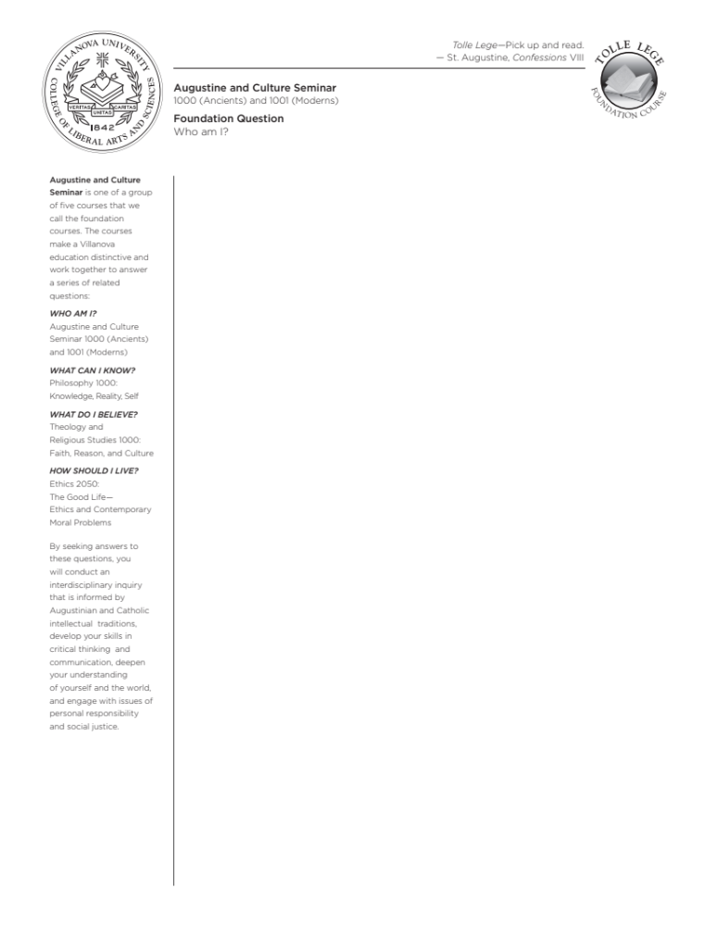
ACS 1001-V03: MODERNS
TR 10:00-11:15am, St. Mary’s 181
Spring 2024

Instructor: Emma V. Slonina, Ph.D.
Email: emma.slonina@villanova.edu
Office: https://villanova.zoom.us/j/6397327350
Office Hours: Wed 10am-12:30pm, Thurs 4:00-6:00pm, and by appointment
Schedule a meeting: https://calendly.com/eslonina/office-hours
Phone: 610-519-3851

Course Description

This course is the second of five that comprise the foundation for your education here at Villanova, “Moderns” being focused on the later developments in Western thought beginning the late 1400s. Here we are particularly concerned with the modification or rejection of the Greco-Roman and Judaeo-Christian traditions, and what that means for our contemporary ideas of who we are, what we want, and how we ought to live.

The foundational question for us in the first two Augustine and Culture Seminars is “Who am I?” This involves asking both who we are as individuals and as human beings. To answer this question, we are going to examine the various ways humans have answered it over the course of history in the West. This way we will discover where our ideas come from, but also confront serious alternatives to the ways we think about ourselves and our lives. We will be challenged by these thinkers, and we will learn how to challenge them in turn.

While we will not definitively answer any of our questions over the course of this semester, this year, or perhaps in our lifetimes, we will develop the critical reading, writing, and thinking skills for pursuing answers long after you have graduated.

Learning Goals

- To read philosophical, religious, and literary texts closely and critically
- To clearly articulate arguments through writing and speaking
- To understand the development of Western thought over time
- To uncover the assumptions about human life that obscure our philosophical ignorance
- To identify and ask the fundamental questions about human life

Responsibilities
As students in this class, you will be expected to complete all reading and writing assignments thoroughly and on time, bring your computers and note taking supplies to every class, and discuss course material respectfully with me and your peers.

As your instructor, I will come prepared every day to teach and discuss course material respectfully with you, respond to all emails within 24 hours (M-F) or 48 hours (Sat & Sun), and grade all assignments within one week of the due date. I reserve the right to make changes to the syllabus and schedule as needed, but I will inform you both via email and in person of any changes in a timely manner.

Attendance
Villanova’s new attendance policy allows students one excused absence for any reason that may contribute to their personal wellness. You must contact me by email before class of your intent to utilize a Personal Day as the reason for your absence. A Personal Day will not be approved retroactively. You may, but are not required to, provide additional information regarding your absence. Additionally, a Personal Day may not:
• be used immediately preceding or following a University holiday or break period;
• be used on days when exams, presentations or other major assignments are scheduled.

A Personal Day does not grant an automatic extension for items due. You remain responsible for all assignments, exams, presentations, etc. due on that date. It is at my discretion to determine whether any extension is appropriate given individual circumstances. If you are absent for an extended period because of serious illness or an emergency, please contact me as soon as possible to discuss accommodations.

Office Hours
You may either visit me in my office (SAC 024) or in my Zoom Room (https://villanova.zoom.us/j/6397327350) for office hours visits. While I promise to be available during my listed office hours, you must go to https://calendly.com/eslonina/office-hours to set up
a meeting even if you want to meet during those scheduled times. When you schedule an appointment on Calendly, it will also ask you whether you want to meet in person or via Zoom. If you can’t make it to any of my office hours, I’m happy to arrange something else with you. In this case, please email me with your availability so we can set something up.

Course Materials
I will provide all our course readings through Perusall, a social annotation software we are piloting
at Villanova. This software allows you to read and annotate with a small group of your peers, ask
me and your classmates questions directly on the reading, keep class notes from our discussions,
and search the digital texts when pulling quotes when writing your papers.

Class Schedule
Week | Assignment | Due date
Week 1  T 1/16  Th 1/18 | Identity and Justice  Reintroduction [no reading]  Martin Luther King, Jr., Audre Lorde
Week 2  T 1/23  Th 1/25 | Shakespeare, Merchant of Venice Acts I-II  Shakespeare, Merchant of Venice Acts III-IV
Week 3  T 1/30  Th 2/1 | Shakespeare, Merchant of Venice Act V; Mock Trial/Paper Workshop  Merchant of Venice Mock Trial [no reading]  Short Paper #1 due | F 2/2
Week 4  T 2/6  Th 2/8 | Human Nature  Locke, Second Treatise Ch I-III  Locke, Second Treatise Ch IV-V
Week 5  T 2/13  Th 2/15 | Rousseau, Second Discourse pgs 76-97 (Letter to Geneva, Preface)  Rousseau, Second Discourse [selections]
Week 6  T 2/20  Th 2/22 | Anna Julia Cooper, Elizabeth Cady Stanton  Soujourner Truth
Week 7  T 2/27  Th 2/29 | Modern Problems  Paper Workshop  Galileo [selections]  Short Paper #2 due
Spring Break M 3/4 – F 3/8
Week 8  T 3/12  Th 3/14 | Galileo [selections]  Galileo [selections]
Week 9  T 3/19  Th 3/21 | Pope Francis I, Laudato Sí  Pope Francis I, Laudato Sí
Week 10  T 3/26  Th 3/28 | Catholic Social Teaching  NO CLASS – Easter Break
Week 11  T 4/2  Th 4/4 | Galileo Mock Trial [no reading]  Paper Work Day [NO CLASS]  Short Paper #3 due | F 4/5
Week 12  T 4/9  Th 4/11 | Who am I? Expressing Ourselves  Frederick Douglass, Autobiography  Frederick Douglass, Autobiography
Week 13  T 4/16  Th 4/18 | Frederick Douglass, “Lecture on Pictures”; Portrait day  bell hooks, Annie Dillard
Week 14  T 4/23  Th 4/25 | Marilynne Robinson  Guest Speaker: Fr. Kevin DePrinzio, O.S.A. [no reading]
Week 15  T 4/30  Th 5/2 | NO CLASS – Friday Schedule [attend your Friday classes]  Portfolio and Conclusion [no reading]  ACS Event Reflections | F 5/3
Finals Week Sat 5/4 – F 5/10
Final paper due Friday, May 10 by 11:59pm

Assignments
All assignments have corresponding detailed guidelines that will be on Blackboard – please read these before beginning your work.

Short Papers
You will write two short papers (4 pages each) that correspond to two of the first three thematic units. They will each respond to a question/set of questions I post on Blackboard.

Final Paper
You will write one longer paper (5 pages) for the final in this class. It will primarily correspond to our final unit but will also involve the other units and the themes we have explored throughout the semester. You will have a few questions to choose from for this paper.

Mock Trial
During two of the first three units, we will be studying two trials (one fictional, one all too real) that reflect conflicts that extend beyond the individuals involved and reflect major tensions between different cultural groups, socioeconomic classes, worldviews, and institutions. Half of the class (~7-8 students) will take on the role of some key figures in the trial and participate in a live mock trial for each unit. The other half of the class will take on the role of the jury and will reach a verdict on the basis of our class version of the trial.

For the “performers,” this will take the place of that unit’s short paper assignment, and it is worth 50 points total.

Participation
There are three dimensions to daily participation: annotations, class discussion, and written reflections. Before coming to class each day that we have reading, you will annotate your assigned texts in your small group on Perusall. These annotations are worth 3 points each day.

We will work through the texts together in class and discuss questions that we pose to the text and to each other. You can earn up to 3 points for in-class participation: 1 for being there and paying attention, an additional 2 for the quality of your contributions during discussions. Contributing can include both answering and asking questions.

There will also be a reflection question you will complete and submit online each class. We will
then reconvene as a class to talk about our responses. These reflections are worth 4 points each: 2
points for simply completing it, and an additional 2 points available for quality responses.

Facilitation
As you progress through your education and your lives, it is increasingly necessary to become an independent learner. To this end, you need to know how to ask questions, and which questions to ask. Each of you will be responsible for bringing your own reflection question for the class to answer, one class period during the semester. We will pick which day you are responsible for at the beginning of the semester. Facilitation will be worth an additional 3 points for the day.

Cultural Events
You are expected to attend 3 “ACS Approved” cultural events throughout the semester and submit
a one page written reflection on your experience for each of them. You can always count an event
(virtual or otherwise) that has the “ACS Approved” distinction (this will be clearly advertised) but
you can propose other activities and events to me – if it is worthwhile and will help expand your
learning experiences from class, I will approve it. You must get approval ahead of time, or risk not
getting credit for an event that doesn’t count. Each of your one-page response papers will be worth
20 points, and will count towards your general participation grade.

Meeting
You need to make an appointment to meet with me at some point during the semester to discuss your writing. I recommend meeting early in the semester to plan your writing and/or to go over feedback in order to make necessary changes and improvements on later assignments.

Portfolio
All students generate a portfolio of work during their time in ACS. You should have created your portfolio last year and submitted the first two assignments. You will submit two more assignments to it from this class by the end of this semester: an analytical paper from ACS 1001 and one final reflection on your writing and intellectual development over the past year.

Final Grade Breakdown
Assignment | Points | Weight
Mock Trial | 50 | 15%
Short papers x2 | 50 each | 30% (15% each)
Final paper | 100 | 25%
Participation  - Class discussion  - Reflections  - Perusall annotations  - Facilitation | 3 daily  5 daily  3 daily (when assigned)  3 | 25%
Office hours meeting  ACS Events (x3)  Portfolio (with final reflection) | 10  20 each (60 total)  20 | 5%

Grading Scale

A 93-100
A- 90-92
B+ 87-89
B 83-86
B- 80-82
C+ 77-79
C 73-76
C- 70-72
D+ 67-69
D 63-66
D- 60-62
F 59 and under

Stacks on Stacks on Stacks (of Resources)
Writing Center
Our Writing Center is one of Villanova’s most-used resources, staffed by students who have been
in your shoes and who know college writing, as well as some professional tutors who have wide-
ranging experience in writing. They also host regular writing workshops that focus on particular
issues common in college papers. Visit their website for information on booking your required
appointment and their schedule of events:
https://www1.villanova.edu/villanova/provost/writingcenter.html

Center for Speaking and Presentation
Many people struggle with public speaking, whether it’s just participating in class or giving a
formal presentation. Not to worry: the Center for Speaking and Presentation, one of Villanova’s
many tutoring and support centers, can help you overcome those public speaking jitters and give
stellar presentations in any type of environment. See their website for more information and to
book an appointment: https://www1.villanova.edu/university/academic-enterprise/student-support/speaking-presentation.html

Falvey Library
Every library is a magical repository of knowledge, providing access to all types of media free of
charge for communities to share. Villanova’s Falvey Library is no different! They host regular
events, house many of our tutoring services, lend out materials on every subject imaginable, and
have tons of librarians who love to help students. Stop by to explore the stacks, and visit their
website to check out their many offerings: https://library.villanova.edu

The Learner’s Studio
You have a wide range of responsibilities as students, including a slew of different classes. Classes
that used to seem easy to you can start tripping you up – whether’s it’s more advanced material, a
heavier workload, or affected by other things going on in your life. Villanova provides tutoring
services in many subject areas. Find more information and book an appointment here:
https://www1.villanova.edu/university/academic-enterprise/student-support/learners-studio.html

Center for Access, Success, and Achievement (CASA)
Villanova’s demographics are changing, making our student body more diverse and bringing a
greater variety of life experiences, backgrounds, and perspectives to our community. It can be
difficult, however, without a community who shares your background or understands your unique
struggles. CASA works to help underrepresented, first-generation, and Pell Eligible students find
community, do their best work, and self-advocate so they can thrive at Villanova and beyond. Visit
their website for more information about their many programs and resources:
https://www1.villanova.edu/villanova/provost/casa.html
The Fine Print

Office of Disabilities (ODS) and Learning Support Services (LSS):
It is the policy of Villanova to make reasonable academic accommodations for qualified individuals with disabilities. Go to the Learning Support Services website (http://learningsupportservices.villanova.edu) for registration guidelines and instructions. For physical access or temporarily disabling conditions, please contact the Office of Disability Services at 610-519-4095 or Stephen.mcwilliams@villanova.edu. Registration is needed in order to receive accommodations.

Academic Integrity
All students are expected to uphold Villanova’s Academic Integrity Policy and Code. Any incident of academic dishonesty will earn you a zero on the assignment in question and be reported to the Dean of the College of Liberal Arts and Sciences for disciplinary action. For the College’s statement on Academic Integrity, you should consult the Student Guide to Policies and Procedures. You may view the University’s Academic Integrity Policy and Code, as well as other useful information related to writing papers, at the Academic Integrity Gateway web site:
https://library.villanova.edu/research/subject-guides/academicintegrity

Absences for Religious Holidays
Villanova University makes every reasonable effort to allow members of the community to observe their religious holidays, consistent with the University’s obligations, responsibilities, and policies. Students who expect to miss a class or assignment due to the observance of a religious holiday should discuss the matter with their professors as soon as possible, normally at least two weeks in advance. Absence from classes or examinations for religious reasons does not relieve students from responsibility for any part of the course work required during the absence. See also: https://www1.villanova.edu/villanova/provost/resources/student/policies/religious holidays.html

All assignments are due at 11:59pm unless otherwise indicated.

