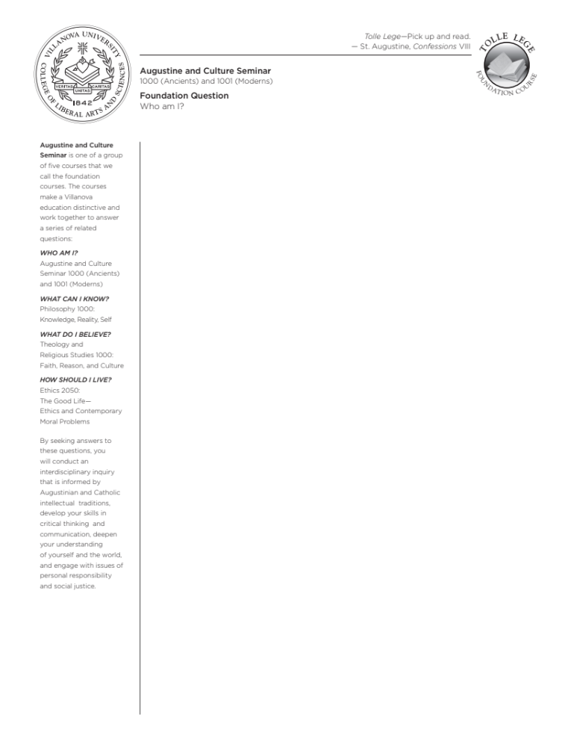
ACS 1000-V03: ANCIENTS
STEM Leadership Communitas
TR 10:00-11:15am, SAC 210
Fall 2023

Instructor: Emma V. Slonina, Ph.D.
Email: emma.slonina@villanova.edu
Office: SAC 024
Virtual office: https://villanova.zoom.us/j/6397327350
Office Hours: Wednesdays 10:30am-12:30pm, Thursdays 4:00-6:00pm, and by appointment
Schedule a meeting: https://calendly.com/eslonina/office-hours
Phone: 610-519-3851

Course Description

This seminar is the first of five courses that comprise the foundation of your education here at Villanova, “Ancients” being focused on the earliest developments in Western thought. Here we are also particularly concerned with the life and work of St. Augustine of Hippo, whose relentless pursuit of the truth will be a model for us in this class.

The foundational question for us in the first two Augustine and Culture Seminars is “Who am I?” This involves asking both who we are as individuals and as human beings. To answer this question, we are going to examine just a few of the many ways humans have answered it over time. This way we will discover where our ideas come from, but also confront serious alternatives to the ways we think about ourselves and our lives. We will be challenged by these thinkers, and we will learn how to challenge them in turn.

While we will not definitively answer any of our questions over the course of
this semester, this year, or perhaps in our lifetimes, we will develop the critical reading, writing, and thinking skills for pursuing answers long after you have graduated.

Learning Goals

- To read philosophical, religious, and literary texts closely and critically
- To clearly articulate arguments through writing and speaking
- To uncover the assumptions about human life that obscure our philosophical ignorance, on our own and with the help of others
- To identify and ask the fundamental questions about human life

Responsibilities
As students in this class, you will be expected to complete all reading and writing assignments thoroughly and on time, bring your texts and note taking supplies to every class, and discuss course material respectfully with me and your peers. You get two “freebie” absences in this class, no questions asked. After that, you will lose participation points for classes that you miss, for whatever reason. If you are absent for an extended period because of serious illness or an emergency, please contact me as soon as possible to discuss accommodations.

As your instructor, I will come prepared every day to teach and discuss course material respectfully with you, respond to all emails within 24 hours (M-F) or 48 hours (Sat & Sun), and grade all assignments within one week of the due date. I reserve the right to make changes to the syllabus and schedule as needed, but I will inform you both via email and in person of any changes in a timely manner.

Office Hours
You may either visit me in my office (SAC 024) or in my Zoom Room (https://villanova.zoom.us/j/6397327350) for office hours visits. While I promise to be available during my listed office hours, you must go to https://calendly.com/eslonina/office-hours to set up
a meeting during those scheduled times. When you schedule an appointment on Calendly, it will also ask you whether you want to meet in person or via Zoom. If you can’t make it to any of my office hours, I’m happy to arrange something else with you. In this case, please email me with your availability so we can set something up.

Course Materials
I will provide all our course readings through Perusall, a social annotation software we are piloting at Villanova. This software allows you to read and annotate with a small group of your peers, ask me and your classmates questions directly on the reading, keep class notes from our discussions, and search the digital texts when pulling quotes when writing your papers.

Our main texts include:
- Plato, Apology of Socrates
- Aristotle, Nicomachean Ethics
- Bible
- Augustine, Confessions
- Native American creation stories
- Boccaccio, Decameron

Class Schedule
Week | Assignment (Listed readings are what we will discuss in class that day) | Due date
Week 1  R 8/24 | Who am I? Who are we? Why are we here?  Introduction — Syllabus  LWL essay due | F 8/25
Week 2  T 8/29  R 8/31 | Allen, “The Aims of Education;” Horowitz, On Looking (selection)  Plato, “Allegory of the Cave;” Apology of Socrates
Week 3  T 9/5  R 9/7 | Ancient Greece: Living by Reason  Plato, Apology of Socrates  Plato, Apology of Socrates
Week 4  T 9/12  R 9/14 | Aristotle, Ethics Bk I  Aristotle, Ethics Bk II; LWL Socrates discussion  LWL Experiment: Socrates begins | F 9/15
Week 5  T 9/19  R 9/21 | The Judaeo-Christian Tradition: Living by Revelation  Genesis 1-4, 12-16, 20-22  Guest Speaker: Seth Pollins M.A., Writing Center Tutor  Short Paper #1/ Socrates LWL logs due | F 9/22
Week 6  T 9/26  R 9/28 | Socrates LWL presentations  Aristotle, Ethics Bk VIII [selections]; Mark 1-4
Week 7  T 10/3  R 10/5 | Aristotle, Ethics Bk VIII [selections]; Mark 5-8  Mark 9-12
Fall Break M 10/9 – F 10/13
Week 8  T 10/17  R 10/19 | Can we live by both Reason and Revelation?  Mark 13-16  Augustine, Confessions Bk I, LWL Jesus discussion  LWL Experiment: Jesus begins | F 10/20
Week 9  T 10/24  R 10/26 | Augustine, Confessions Bk II-III  Augustine, Confessions Bk IV-V  Short Paper 2/Jesus LWL logs due | F 10/27
Week 10  T 10/31  R 11/2 | Jesus LWL presentations  Augustine, Confessions Bk VI-VII
Week 11  T 11/7  R 11/9 | Augustine, Confessions Bk VIII  Augustine, Confessions Bk IX, LWL Augustine discussion  LWL Experiment: Augustine begins | F 11/10
Week 12  T 11/14  R 11/16 | Native American Creation Stories [assignment on Bb]  Kimmerer, “Allegiance to Gratitude”  Short Paper #3/Augustine LWL logs due | F 11/17
Week 13  T 11/21  R 11/23 | Boccaccio, Decameron  THANKSGIVING – NO CLASS
Week 14  T 11/28  R 11/30 | LWL Augustine presentations  Boccaccio, Decameron
Week 15  T 12/5  R 12/7 | Boccaccio, Decameron  Portfolio and Conclusion [no reading]  ACS Event Reflections | F 12/8
Finals Week Wednesday 12/13 — Tuesday 12/19
Final paper due Monday, December 18 by 11:59pm EST

Assignments
All assignments have corresponding detailed guidelines, examples of work, and grading rubrics that will be on Blackboard – please read these before beginning your work.

Short Papers
You will write two short papers (4 pages each) that correspond to two of our course units. You will have a few questions to choose from for each paper. These are worth 50 points each. You will write a third, final paper of similar length synthesizing the work we have done throughout the semester together.

Life Well-Lived Experiment
During one of the first three units, we will be studying an inspirational figure whose life and works have inspired others for hundreds of years. As we consider what a “life well-lived” is throughout the semester, we will test out living like one of these figures to see if living like them means living well, and what that looks like for humans today – if it’s possible at all. A small group (~5 students) each unit will live like the unit’s central figure for a week, record their experiences, and present them to the class. This will take the place of that unit’s short paper assignment, and is worth 100 points total.

Participation
There are three dimensions to daily participation: annotations, class discussion, and written reflections. Before coming to class each day that we have reading, you will annotate your assigned texts in your small group on Perusall. These annotations are worth 3 points each day.

We will work through the texts together in class and discuss questions that we pose to the text and to each other. You can earn up to 3 points for in-class participation: 1 for being there and paying attention, an additional 2 for the quality of your contributions during discussions. Contributing can involve both answering and asking questions.

There will also be a reflection question you will complete and submit online each class. We will then reconvene as a class to talk about our responses. These reflections are worth 4 points each: 2 points for simply completing it, and an additional 2 points available for quality responses.

Cultural Events
You are expected to attend 3 “ACS Approved” cultural events throughout the semester and submit a one page written reflection on your experience for each of them. You can always count an event (virtual or otherwise) that has the “ACS Approved” distinction (this will be clearly advertised) but you can propose other activities and events to me – if it is worthwhile and will help expand your learning experiences from class, I will approve it. You must get approval ahead of time, or risk not getting credit for an event that doesn’t count. Each of your one-page response papers will be worth 20 points, and will count towards your general participation grade.

Meetings
You need to make an appointment to meet with me at some point during the semester to discuss your writing. I recommend meeting early in the semester to plan your writing and/or to go over feedback in order to make necessary changes and improvements on later assignments.

You also need to make an appointment at the Writing Center at some point in the semester, to work with one of our awesome writing tutors. They can help you with your writing at any stage – from brainstorming to final edits, but they are not proofreaders. They are there to help you substantively. I recommend going to them after having met with me so you know what the expectations are for your writing in this class. They get very busy at the end of the semester; make your appointment early!

Portfolio
All students generate a portfolio of work during their time in ACS. We will spend the last day of class creating the portfolio together and filling it with work from this semester.

Final Grade Breakdown
Assignment | Points | Weight
Short papers x2 | 50 each | 30% (15% each)
LWL Experiment | 100 | 25%
Final paper | 50 | 15%
Participation  - Class discussion  - Reflections  - Perusall annotations  ACS Events (x3) | 3 daily  4 daily  3 daily (when assigned)  20 each (60 total) | 25%
Writing Center meeting  Office hours meeting  Portfolio | 10  10  20 | 5%

Grading Scale

A 93-100
A- 90-92
B+ 87-89
B 83-86
B- 80-82
C+ 77-79
C 73-76
C- 70-72
D+ 67-69
D 63-66
D- 60-62
F 59 and under

Stacks on Stacks on Stacks (of Resources)
Writing Center
Our Writing Center is one of Villanova’s most-used resources, staffed by students who have been in your shoes and who know college writing, as well as some professional tutors who have wide-ranging experience in writing. They also host regular writing workshops that focus on particular issues common in college papers. Visit their website for information on booking your required appointment and their schedule of events: https://www1.villanova.edu/villanova/provost/writingcenter.html

Center for Speaking and Presentation
Many people struggle with public speaking, whether it’s just participating in class or giving a formal presentation. Not to worry: the Center for Speaking and Presentation, one of Villanova’s many tutoring and support centers, can help you overcome those public speaking jitters and give stellar presentations in any type of environment. See their website for more information and to book an appointment: https://www1.villanova.edu/university/academic-enterprise/student-support/speaking-presentation.html

Falvey Library
Every library is a magical repository of knowledge, providing access to all types of media free of charge for communities to share. Villanova’s Falvey Library is no different! They host regular events, house many of our tutoring services, lend out materials on every subject imaginable, and have tons of librarians who love to help students. Stop by to explore the stacks, and visit their website to check out their many offerings: https://library.villanova.edu

The Learner’s Studio
You have a wide range of responsibilities as students, including a slew of different classes. Classes that used to seem easy to you can start tripping you up – whether’s it’s more advanced material, a heavier workload, or affected by other things going on in your life. Villanova provides tutoring services in many subject areas. Find more information and book an appointment here: https://www1.villanova.edu/university/academic-enterprise/student-support/learners-studio.html

Center for Access, Success, and Achievement (CASA)
Villanova’s demographics are changing, making our student body more diverse and bringing a greater variety of life experiences, backgrounds, and perspectives to our community. It can be difficult, however, without a community who shares your background or understands your unique struggles. CASA works to help underrepresented, first-generation, and Pell Eligible students find community, do their best work, and self-advocate so they can thrive at Villanova and beyond. Visit their website for more information about their many programs and resources: https://www1.villanova.edu/villanova/provost/casa.html

University Counseling Center
You are not simply students; you are human beings, with all of humanity’s attendant hopes, dreams, fears, and struggles. Transitioning to college is difficult, and you may find yourself struggling to face things you’ve never had to deal with before. We all need help in our lives, and when you’ve just left behind your support network, it’s not clear where to turn. While your faculty and staff here at Villanova want to help you succeed, sometimes you need specific and/or professional help. Visit the University Counseling Center website to learn about mental health services available to you: https://www1.villanova.edu/university/student-life/health-services/counseling-center.html

The Fine Print

Office of Disabilities (ODS) and Learning Support Services (LSS):
It is the policy of Villanova to make reasonable academic accommodations for qualified individuals with disabilities. Go to the Learning Support Services website (http://learningsupportservices.villanova.edu) for registration guidelines and instructions. For physical access or temporarily disabling conditions, please contact the Office of Disability Services at 610-519-4095 or Stephen.mcwilliams@villanova.edu. Registration is needed in order to receive accommodations.

Academic Integrity
All students are expected to uphold Villanova’s Academic Integrity Policy and Code. Any incident of academic dishonesty will earn you a zero on the assignment in question and be reported to the Dean of the College of Liberal Arts and Sciences for disciplinary action. For the College’s statement on Academic Integrity, you should consult the Student Guide to Policies and Procedures. You may view the University’s Academic Integrity Policy and Code, as well as other useful information related to writing papers, at the Academic Integrity Gateway web site:
https://library.villanova.edu/research/subject-guides/academicintegrity

Absences for Religious Holidays
Villanova University makes every reasonable effort to allow members of the community to observe their religious holidays, consistent with the University’s obligations, responsibilities, and policies. Students who expect to miss a class or assignment due to the observance of a religious holiday should discuss the matter with their professors as soon as possible, normally at least two weeks in advance. Absence from classes or examinations for religious reasons does not relieve students from responsibility for any part of the course work required during the absence. See also: https://www1.villanova.edu/villanova/provost/resources/student/policies/religious holidays.html

All assignments are due at 11:59pm unless otherwise indicated.

